PINEWOOD DERBY™ OFFICIAL RULES
The specifications below will be strictly adhered to for the 2018 Pinewood Derby. These rules supersede the rules that were provided in the Pinewood Derby kit.

ELIGIBILITY
- A Scout is Trustworthy

- All Cub Scouts of Pack 229 are eligible to compete.

- Scouts be present at Check-In.

- Each car must pass inspection by the Official Inspectors before it may compete.
The Inspectors have the right to disqualify cars which do not meet these specifications.
If your car does not meet these specifications, it will not be permitted to run in the race until it has been corrected. We encourage you to check-in early in case you need to make any minor adjustments.

- No handling of the car by participants is allowed after the car receives official inspection approval. Pictures of the Scout with his car must be taken before Check-In or after all racing is completed.

- Once a car is accepted by the inspectors at Check-In, no challenges or additional inspections will be performed.

CONSTRUCTION
- Prior Use: Cars raced in previous years are not allowed.

- Materials: Cars are to be made from the Official Boy Scout Pinewood Derby Kit.
Replacement kits are available at the Scout shop. Any replacement parts shall be Official Boy Scout Pinewood Derby parts. (If you buy it on the Internet, it is almost certainly NOT official BSA, even if they’ve put the logo on it. Buy the kit at the Scout Shop.)
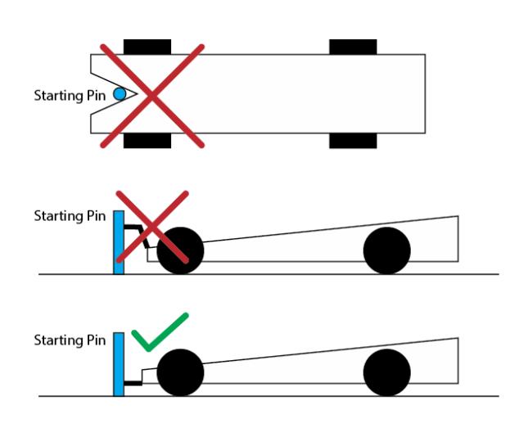
- Shape: The center of the front bumper must be the furthest point forward on the car with the front bumper center being no more than ¼” higher than the undercarriage clearance of the car. No part of the car may extend forward of the starting pin. The front of the car must not have a notch, as pictured. Note that ‘pointed nose’ cars are hard to start. We will do our best.

- Clearance: Minimum ground clearance must be 3/8 inch as measured between the car and the track. (We recommend that you recess weights placed on the underside of the car.)

- Length: The length of the car shall not exceed 7 inches.

- Height: The height of the car shall not exceed 4-1/2 inches.

- Width: The width of the car shall not exceed 2-3/4 inches. Minimum width between wheels (on the same axle) shall not be less than 1-3/4 inches. The car body can be narrower than 1-3/4 inches, cut the wheels must be a minimum of 1-3/4 inches wide so the car will straddle the track.

8. Axles: All cars must use slot in original block of wood for axle placement. No changes in axle distance or drilling of axle holes in the side of the car with a drill press will be allowed. Axle distance is 4 3/8 inches from the center of the front axle to the center of the back axle. Slot depth may not be altered.

No solid axles (PineCar brand or similar) will be allowed. Only axles as provided with
the Official Pinewood derby kit will be allowed (4 nails, 1 per wheel). No wheel covers, or hubcaps are allowed. Axle shape and dimensions may not be altered. Only burr marks may be removed, and axles may be lightly sanded and/or polished.

- Weight: The weight of the car shall not exceed 5.0 ounces. No loose or liquid materials of any kind are permitted in or on the car. The car may be hollowed out and built up to the maximum weight by the addition of wood, metal, plastic, glue, etc., provided it is securely built into the body.

- Wheel Bearings: Washers, bearings, and bushings are prohibited.

- Springs: The car shall not ride on any type of springs.

- Detailing: Details such as steering wheel, driver, decals, painting, and interior detail are
permissible if these details do not exceed the maximum length, width, or weight. All details must be permanently attached.

- Power: Each car must be free-wheeling, powered only by gravity with no starting device.

- Wheels: If the wheels on your car do not meet the rules, you will not be allowed to race. Cars must be run with the official BSA wheels that come in the kit purchased at the Scout Shop. Colored or other replacement wheels purchased at the Scout Shop are also acceptable. Wheels purchased from the Internet, even if they have “BSA” on them are NOT acceptable.

Surface imperfections and mold casting marks may be removed with light sanding
and/or polishing, but wheels may not be altered in any other way, including holes
drilled in the side, tread width narrowed, or the inside surface of the wheel carved out.

Tread (indicators) marks on the outside edge of the wheel must be clearly visible on all
4 wheels. A wheel CANNOT be tapered to a sharp edge or radius (See picture,
below).

You cannot mount the wheels to be angled. All 4 wheels need to be mounted straight on the vehicle. Each wheel’s flat surface needs to be touching the ground while the car is in motion.
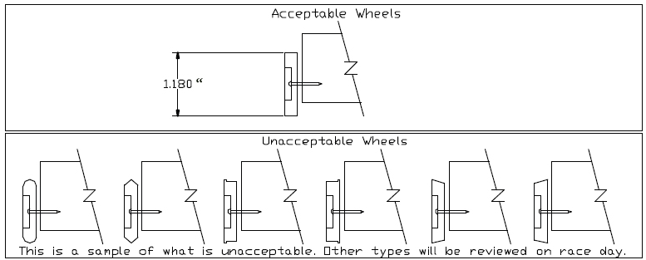

- Lubricant: Graphite or other dry type lubricants will be the only lubricants allowed. No other types will be permitted. Lubrication must be done prior to official inspection only. PLEASE LUBRICATE THE FRICTION POINTS, NOT THE OUTSIDE OF THE WHEEL.

SPORTSMANSHIP
- Behavior unbecoming of a Scout by a participant or their parent/adult guardian may
result in the participant’s car being disqualified. Judges will generally warn casual
infractions, but argumentative or abusive behavior will NOT be tolerated.

- Any empty lane(s) will be filled with a “Pace Car” so that all lanes are filled for every run
down the track.

- Judges’ determinations as to race winners are final.

- Scoring: Every car will run the same number of times on each lane of its assigned track.
The finishing positions will be awarded based on the lowest total time for the car after all
passes down the track. In the highly unlikely event that there is a tie in cumulative times,
(we measure to the 0.001 second), all cars that are tied for a position will draw a lane and
will make one pass down that lane. The position that they finish will be used to break the
tie.

DESIGN COMPETITION
The Design Contest will be scored in each of the following categories:

- Uniqueness/Imagination (0-5 points)
This area will evaluate the conceptual thinking the Scout gave to his work as well as his attention to meeting all official derby specifications. Example: A car looking like a unique object such as a pencil, arrow, or futuristic sports car.

- Craftsmanship (0-5 points)
The section will consider the effort that was put into the fit and finish of the vehicle by the Cub Scout. Example: The smoothness of the surface, fit of the parts, gloss of the paint, etc. are checked.

- Color Usage (0-5 points)

- Here the usage of color is judged. Example: How and where different colors are used.
Detailing (0-5 points)
This is the area where the blending of all the parts that make up the car is evaluated. Example: How does the usage and placement of all parts contribute to the overall appearance?

5. Graphics (0-5 points)
The utilization of numbers, decals, painted symbols, etc. is judged as they relate to the car. Example: Here the judges would rate the contributions these items make toward the overall appearance of the car in the same way icing decorates a cake.

6. Scout Participation (0-10appears to have been prepared by a Cub Scout.

Judges’ determinations as to winners are final.

PINEWOOD DADDY ™

This is the race for parents, grandparents, and adult loved-ones of the Scout!

- All rules that apply to the scout will also apply to the adults with the following exceptions:

- Prior Use: You are welcome to use cars raced in prior years as long as it meets the official rules. Had a great car as a kid?... let’s see how it races today!!

- Design: There will be no design competition for adults.

2. Set a good example for the kids.

